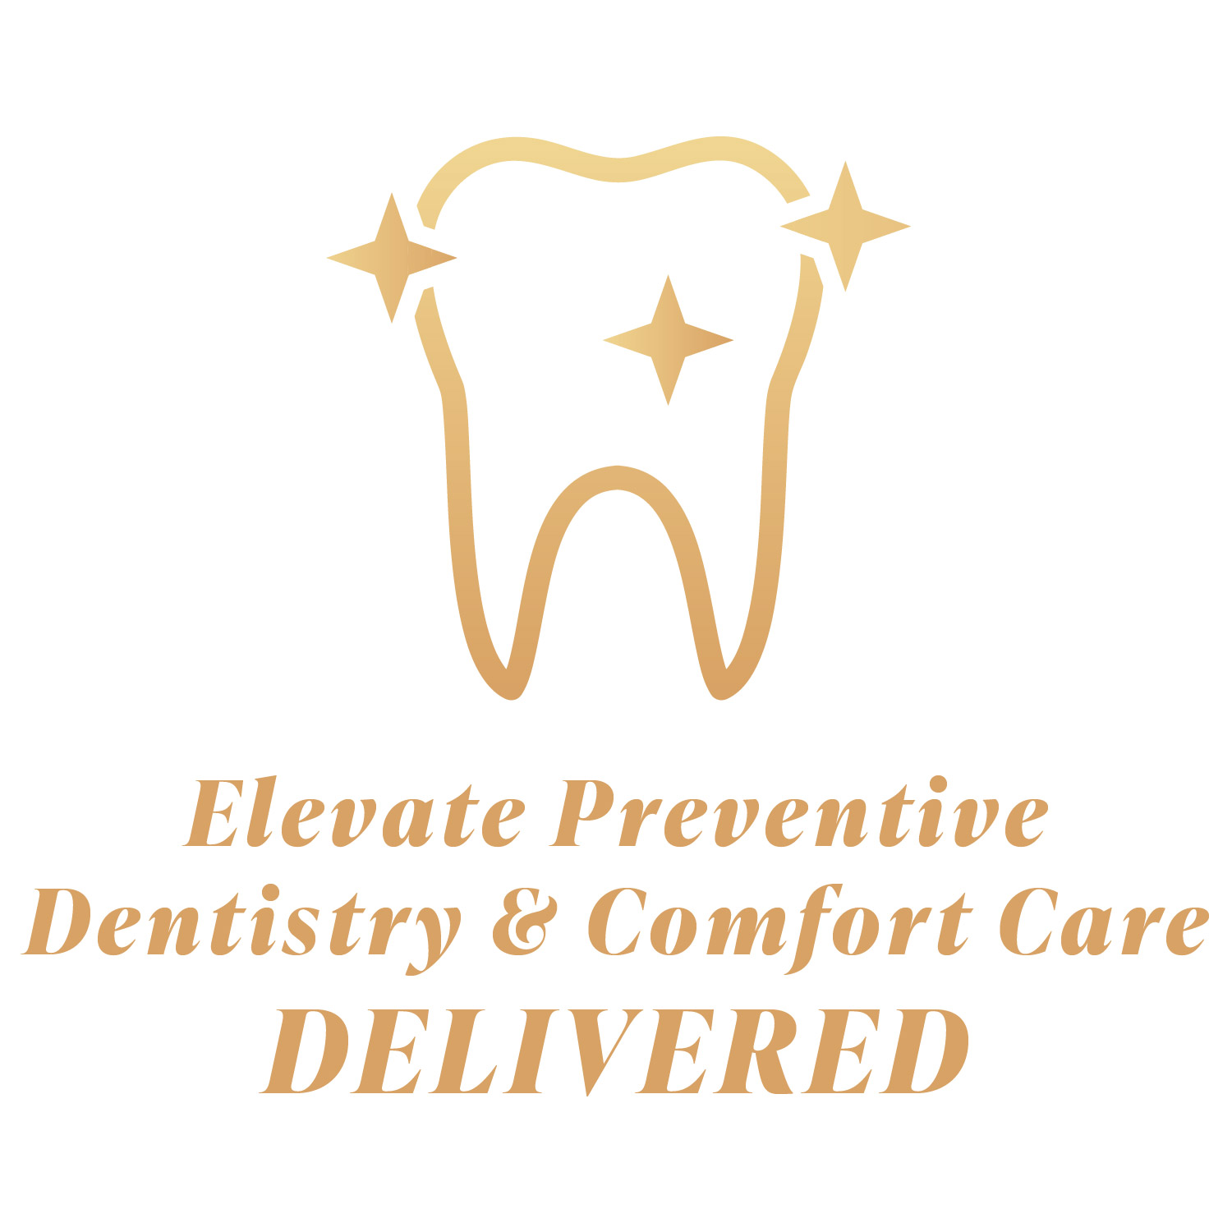

Lucy Torres RDHAP

*Registered Dental Hygienist in Alternative Practice*

Phone: 707-337-8895

Smilesaver1@gmail.com

GENERAL INFORMATION FOR INFORMED CONSENT FOR DENTAL HYGIENE TREATMENT

The following information is provided to assist you in giving an informed consent for dental hygiene services. Lucy Torres RDHAP is a local Dental Hygienist in Alternative practice, and this special licensure is specifically for the access to dental hygiene care for the elderly and disabled. Rachel has been a Registered Dental Hygienist in California since 2009 and received her additional licensure in Alternative Practice. Rachel holds licenses as both an RDH (license #24740) and an RDHAP (license #HAP856) in California.

Dental Hygiene procedures are generally very safe. However, dental hygiene treatment is not guaranteed. Many factors contribute to the success or failure of treatment including but not limited to: existing oral conditions, extent and severity of infection, ability of resident to tolerate treatment, quality and frequency of daily oral care. Dental hygienists provide on preventative or therapeutic services defined in the California Dental Practice Act. A referral to a licensed dentist or physician will be made for all other conditions, for example: dental decay, tooth extraction, fabrication of dentures or partials, intra and extra oral lesions, etc. A recommendation for a referral to a dental specialist such as an Oral Surgeon or Periodontist (gum specialist) is made only in very specific cases. An annual dental examination by a general dentist is routinely recommended for dental diagnosis and dental treatment. For all referrals, the resident/responsible party is responsible for the selection of the dentist. Rachel Watts, RDHAP assumes no responsibility for diagnosis, treatment plan or treatment provided by the licensed dentist. All concerns or questions regarding dental care must be directed to the dentist.

Prior to dental hygiene treatment, the resident’s physician or dentist will be requested to give consent (prescription) for dental hygiene care and provide orders to the nursing home for any pre or post treatment medications, or any necessary alteration in routine medications. Drugs such as antibiotics, sedatives, anti-anxiety agents, or analgesics may be ordered when needed based on the resident’s health status. Antibiotics may be used to prevent infections that may result when bacteria from the mouth enter the bloodstream. Bacteremias can affect individuals with certain heart conditions, prosthetic join replacements, and other conditions. Sedatives, anti-anxiety agents, analgesics may be used for comfort, safety, and/or stress reduction during/after treatment. Injectable anesthetics (i.e. Novacaine, Lidocaine, etc) may be used if deemed necessary, but nitrous oxide-oxygen sedation is **NOT** used. Administration of any drug carries a slight element of risk. Adverse effects can range from mild to severe and may include allergic reaction, skin rash, swelling, pain, cardiac and respiratory dysfunction, and in very rare instances death. You may discuss medication and anesthetic concerns with the resident’s physician and/or dental hygienist.

By signing below I acknowledge the above information and give my consent to receive dental hygiene treatment for myself or the resident I am responsible for.

Patient/responsible party: _______________________________ Date: ________________________